Nov 29, 2024
Ref: IIH/MD/2024/11/007

His Excellency,
The Executive Governor of Kwara State,
Government House,
Ahmadu Bello Way,
GRA, Ilorin, Kwara State

Your Excellency Sir,

REQUEST FOR APPROVAL TO RELEASE FUNDS FOR PAYMENT OF KWARA STATE GOVERNMENT GOOGLE WORKSPACE EMAIL & COLLABORATION TOOLS FOR
ENTIRE YEAR JAN-DEC 2025

I write to request the funds for 1 year renewal of the GSuite (Google Workspace Collaboration Tools) email addresses for Kwara State Government Principal officers for the period of Jan 2025 – Dec 2025. The last request was made at the rate of N1210/$ last year, today it’s N1750/$. Due to the fact that these costs are all billed in dollars and the recent increase of the dollar against the naira, I humbly ask this be treated quickly before any further increase in rate.

SN | DESCRIPTION | QTY | RATE | DURATION | PRICE ($) | PRICE (N)*
 | Kwara State .gov Email
1 | Google Workspace Business Edition | 80 users | $12/user | 12 months  Jan-Dec 2025 | 11,520 | 20,160,000
2 | Service Charge + VAT 20%** |  |  |  |  | 4,032,000
 | GRAND TOTAL |  |  |  |  | 24,192,000

* This conversion was done at the current market rate of USD1 = NGN1750 as at Nov 29, 2024
** Service charge is to cover statutory government deductions, taxes and transaction charges as the costs are paid in full directly to Google, a third party vendor with no local payment option via debit/credit card online

I thankfully anticipate prompt payment so as to avoid disruption of service and continued smooth communication and collaboration within the State Government.

Yours sincerely,
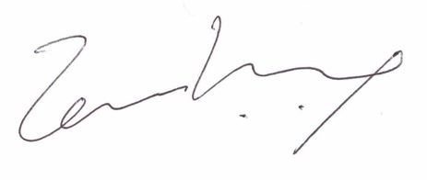
Temi Kolawole
Managing Director

